**Deliverable – 5**

**Understanding In-app Ads and Detecting Hidden Attacks through the mobile App -Web Interface.**

Table of Contents

I. Project Details 6

II. Requirement Specification for Phase - 2 7

1.1 Admin Module Requirements: 6

1.2 User Module Requirement: 8

2. Non-Functional Requirements Developed Under Phase - 2 12

2.1 Security Requirements: 12

2.2 Privacy Requirements: 12

2.3 Scalability and performance Requirements: 12

2.4 Usability Requirement: 12

2.5 Compatibility Requirement: 12

3. Interfaces (user, hardware, software, and/or communication) Developed Under Phase - 1 12

3.1 Hardware Interface Requirements: 13

3.2 Software Interfaces Requirements: 13

3.2 User Interface: 13

III. UML Design 16

1. Class diagram 16

2. Sequence diagram 17

3. Use case diagram 18

IV. Test Cases 20

V. User Manual for Phase - 1 31

VI. Program Compilation and Run Instructions 55

1. Program Instructions 55

2. Testing Instructions 56

VII. Feedback 56

VIII. Accomplishments 57

IX. Member contribution table 57

# PROJECT DETAILS

**Project Title: Project Title:**  **Understanding In-app Ads and Detecting Hidden**

**Attacks through the mobile App -Web Interface.**

**Group Name:** Team Resolve

**Group Members:**

1. Navyasri Arekatla
2. Lokesh Bachu
3. Sushma Bobbishetty
4. Naveen Bolgom
5. Sathvik Cheekati
6. Vamshi Teja Goud Puli
7. Shiva Teja Reddy Yammanuru

# Requirement Specification for Phase - 2

## Functional Requirements Developed under Phase – 2 with respect to each module

Phase 2 has seen the addition of a few new functionality and the modification of a few already-existing features.

### Admin Module Requirements:

#### Registration :

• In addition to the project, the server must also be started. This gives us access to the project dashboard and all associated files.  
• During the registration process, administrators must enter the data required to register with the browser.  
• Our system does not use a browser; Apache is used instead. Web pages are served to users through software known as Apache, which acts as a web server listening and responding to HTTP requests sent by users. • The "Admin Login" button is located on the home page and clicking on it will start the administrator registration process. You will then be prompted to enter your company email and password.  
• Users who click the button are directed to a page that requires them to register.

• Following the administrator's enrollment in the course. Now is a good time to use the browser.

#### Login Validation:

• To login, the administrator must click on the icon labeled Admin Login. The person's credibility was thoroughly investigated.  
• The error message "Invalid user name or password" is displayed if any of the information is incorrect.  
• If you go to your settings and select "Forgot Password", you have the option to change your password at any time. Each of the password-related fields (Email ID, Contact Number, New Password, and Confirm Password) are currently blank. If the correct email id and contact number are provided, the passwords can be updated successfully. If you select "Cancel", the update will no longer be downloaded.

#### Dashboard Display:

Admin Dashboard has following sections:

##### ADMIN MENU:

The admin has access to a variety of settings through a menu called "Admin" which offers a variety of options.  
The admin accesses are the following:

**View all users and authorize**: We are able to review all user requests and allow or deny them as appropriate. The administrator is the only one who can create authorized users, and those users are the only ones who can access the user dashboard.

**View all android users**: This module contains information about all Android users.  
**View advertisement request users:** This section displays advertisements requested by the user. We are able to honor the request using this interface.  
 **View friend request and responses:** This section of the module displays all friend requests and responses to those requests.  
**View All user’s advertisement with rank and rating** In this section, all ads registered by users are compiled and displayed with their position and score. This module gives users the ability to access information associated with the malicious user.

**View all Malicious user details:** This gives the admin the ability to identify malicious people and block those people from accessing additional advertisements.  
**View all advertisement recommended users details:** This module displays advertisements recommended by other users.  
**View malicious publishers:** This component provides the administrator with a list of all malicious publishers reported by users. This module helps administrators determine how to avoid fake publishers for advertising purposes.

**View all android hidden attackers:** This module grants the admin the ability to see all hidden Android attackers and it is useful for this purpose.  
**View all expired advertisements:** This module gives the admin the option to view all the expired listings since.  
**View all blocked users :**This module allows you to view all users who have been blocked by the administrator.  
**View all blocked user’s evidence:** This module provides the administrator with a complete overview of all evidence associated with blocked users.  
**View user type count in chart** Admin can use this module to display all the type counts given in the chart to the user. This gives the admin the ability to view all ad rankings in the order they were received.

**View all advertisement ranks in chart:** The admin can check this and see where each of his ads are currently in the ranking.  
**Logout**: Selecting this option allows the admin to completely log out of the dashboard

### 1.2 USER REGISTER MODULE Requirement:

#### Registration:

• Users must create an account with us and provide us with relevant information in order to use our web browser. This information consists of their professional email address and the password required to access the relevant account. Without the Apache program running in the background, our web browser would not work.  
• Users can start the registration process by selecting “User Registration Login” from the website menu. He must then enter his e-mail address and choose a password. After clicking the button, the registration page opens and asks them to enter the necessary information.  
• User can access their accounts through a web browser and log in after completing the registration process. As a result, they can use all the features and functions of our web browser.

#### Login Validation:

• Users can access the dashboard and register. In order to use this service, users must first register on the website and provide essential information. After successful registration, users can log in to the user module.  
• To access the user module, users must select "USER" from the dashboard menu and then enter their credentials. A user must first register as a user and have this registration approved by the administrator before being able to access the user module.

#### Dashboard Display:

Only after the admin approves the user request does the user dashboard appear. The user will pass the request to the admin if he wants to keep an ad on the dashboard to promote his ads.

##### User menu:

The User Dashboard provides a comprehensive overview of all features available to the user.

##### Profile:

The person's information is available in the profile. User information is specified in this module.

###### Search friends:

With this module we can search for friends and find new ones. We can find our friends and invite them.

###### Manage bank accounts:

Part of the system tells the user his account. In this form, users can enter their bank account details and register their bank account. Users can also view their account statement through this form.

##### send request to admin to launch advertisement:

* Here we record the date and time we want the announcement to appear. The administrator will then review the request and give the green light.
* After your application has been approved, we will have to pay to place your ad.

##### add advertisement details:

•Once the administrator has approved our request for an ad, we can now add the information for our ad in the appropriate browser.  
• Requests information such as browser category, name, file, content and ad length.  
Using this module you can see the ads that have been loaded along with how long each ad will be active.  
• You also have the option to remove ads you no longer want to see. • Using this module, you can view the adverts that have been published, together with the length of time each advert will remain active.  
• You also have the option to remove advertisements that you no longer want to see.

##### all my friends advertisement details and recommend to other friends:

* In this module we can view the announcements of our friends and recommend them to other friends.

##### friends recommended advertisements:

* With this module you can see which ads have been placed and for how long each ad will be displayed. You can also remove ads that you no longer want to see.

##### Logout:

Users can logout just by clicking this button.

## Non-Functional Requirements Developed Under Phase - 1

### Security Requirements:

Using Java and JavaScript functions in the application HTML file to implement user authentication ensures the security of the application. This means that users must enter their credentials to access the application and the application authentication system checks that the information is correct.  
The application can also be used only on websites that have given permission for this. This helps prevent unauthorized access and ensures that the app is only used as intended. If you try to run the application on a website that shouldn't have it, it won't work.

### Privacy Requirements:

Apart from the user's email address, which they submit to complete the registration process, the application you are referring to does not disclose any personal data about its users. JavaScript is used during the registration process to verify the user's identity and confirm that they are authorized to use the program. This ensures that only authorized users can access the application. Basically, before the user is allowed to access the features of the program, the app performs verification using the email address and password that the user has provided to the app.

### Scalability and performance Requirements:

This app provides users with a web-based platform that allows them to not only create and manage their own ads, but also connect with each other. To use this platform, we need a cloud server and a domain to host the application on. This project is comparable in complexity and scope to larger projects.

### Usability Requirement:

It is essential to place a lot of emphasis on application usability while developing the application for end users. Using different types of technology like Ajax, jQuery and Java is one of the most effective ways to make an application more user-friendly.  
The user can use the application without having to reload the entire page as Ajax allows for asynchronous communication between the front end and the back end of the application. This can help improve the user experience by reducing the time users wait for the program and increasing the responsiveness of the software.  
The jQuery JavaScript library simplifies the process of interacting with a web page's Document Object Model (DOM). DOM stands for "Document Object Model". When developers write code using jQuery, the resulting code is shorter, clearer, and easier to read and maintain, helping to improve the end-user experience.  
Java is a widely used computer language due to its reputation for scalability and performance. Developers are able to design robust and reliable systems that can handle massive amounts of data and traffic when they use Java on an application's backend to build the application. The combination of these technologies has the potential to help software developers produce programs that are more user-friendly, intuitive, and responsive to end-user needs.

### Compatibility Requirement:

Running our application on following browsers is more compatible:

1. Chrome Browser Version 98.0.0.0 or above
2. Microsoft Edge Version 90 or above
3. Safari Browser Version 13.1.2 or above

## Interfaces (user, hardware, software, and/or communication) Developed Under Phase - 2

### Hardware Interface Requirements:

This application can be runed on a web browser which is installed on **Laptop / PC**.

### Software Interfaces Requirements:

1. **HTML**: For website Designing.
2. **JQUERY:** For styling the website Design.
3. **AJAX:** Used for Dynamically loading the webpages.
4. **JavaScript**: This Technology is used to apply validations for web pages and redirections etc.,
5. **SQL:** We will be using SQL for accessing the database.
6. **Visual Studio:** We will be using Visual Studio as Integrated Development Environment for the Project.
7. **Apache Tomcat:** It is used as a server for deploying the application.

### User Interface:

Here is the Landing page of the application.

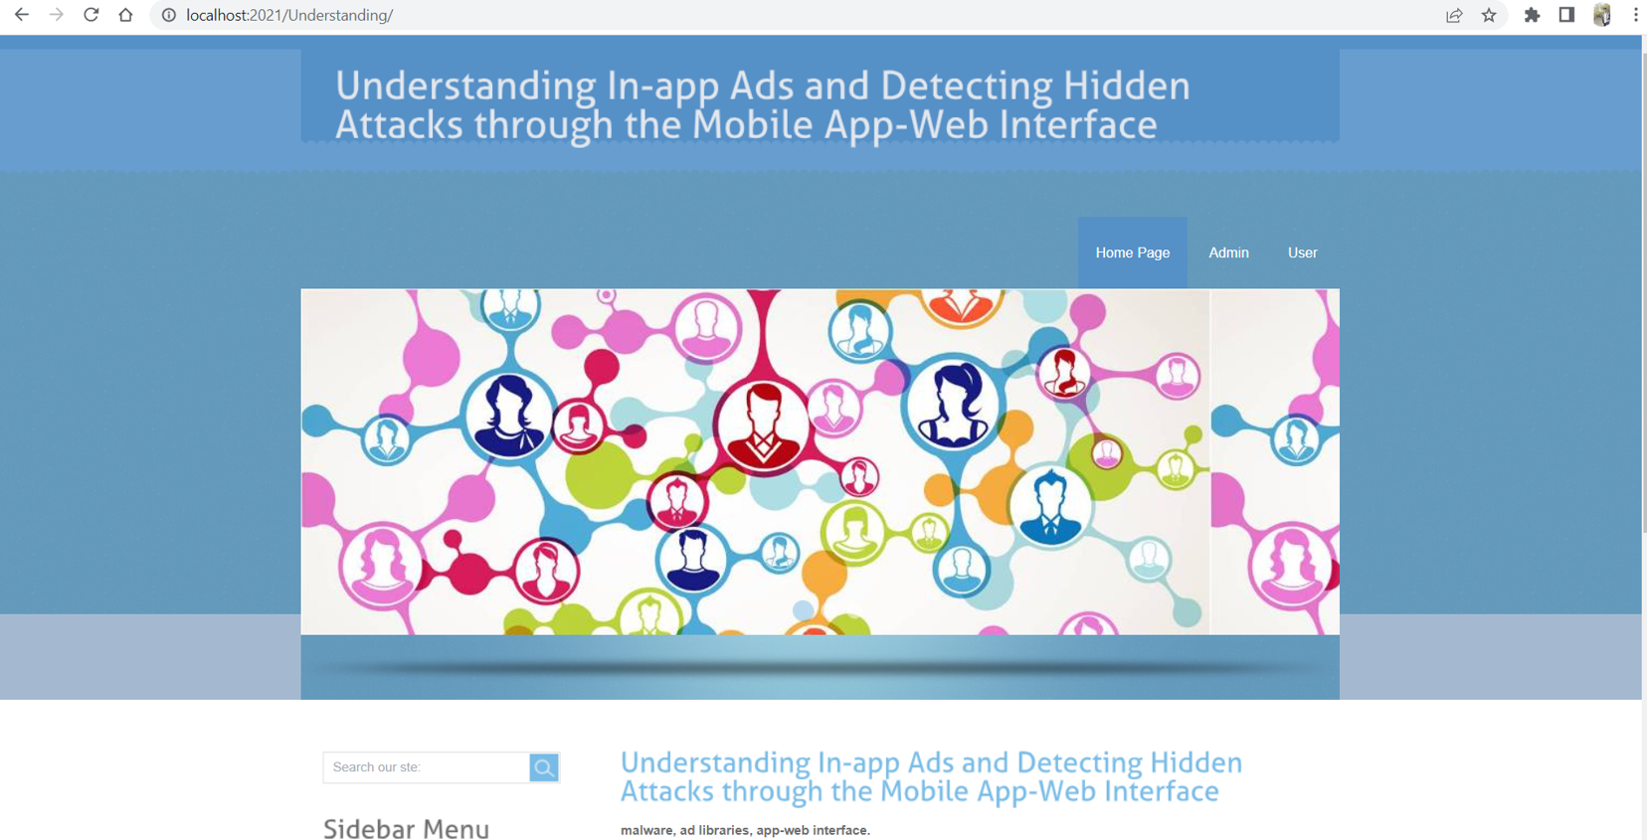

Step 2: This page displays the menu options like Home, Admin, User

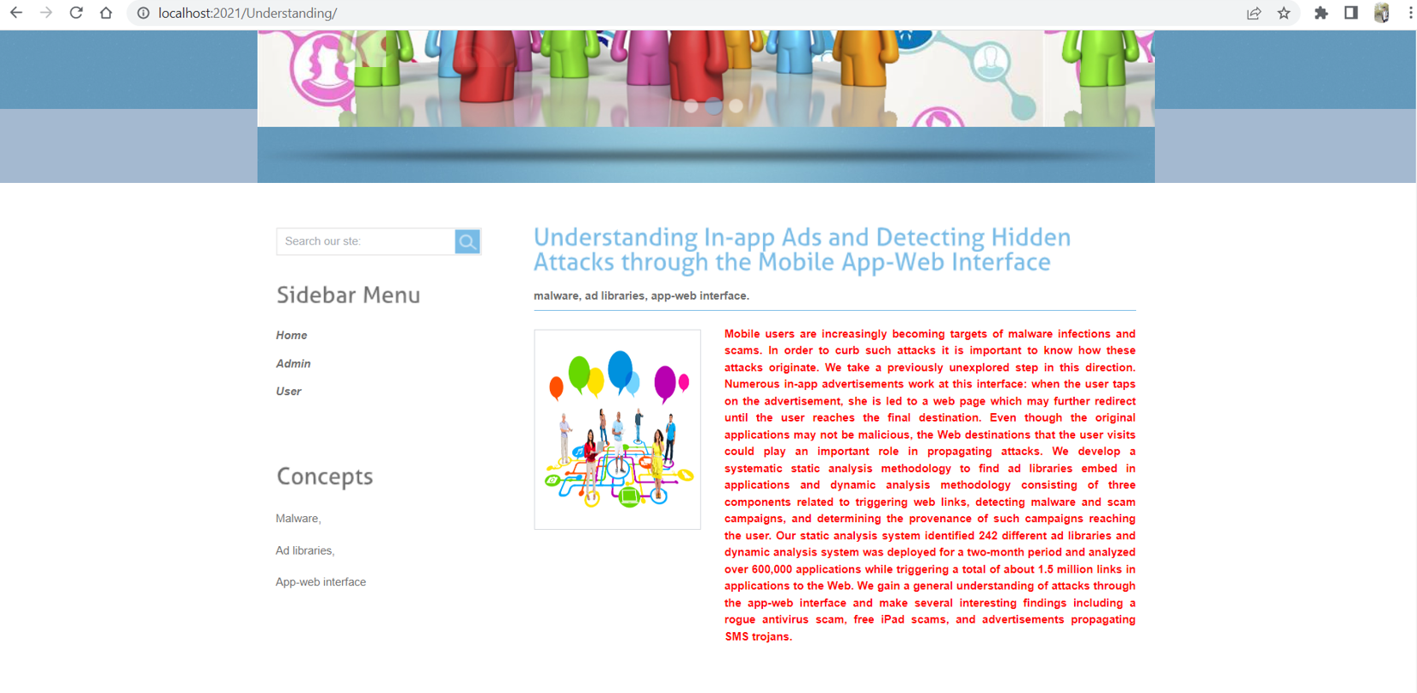

Step 3: By selecting the user from the menu we can land into this page. That is User Login page. As the new user we need to select Register here.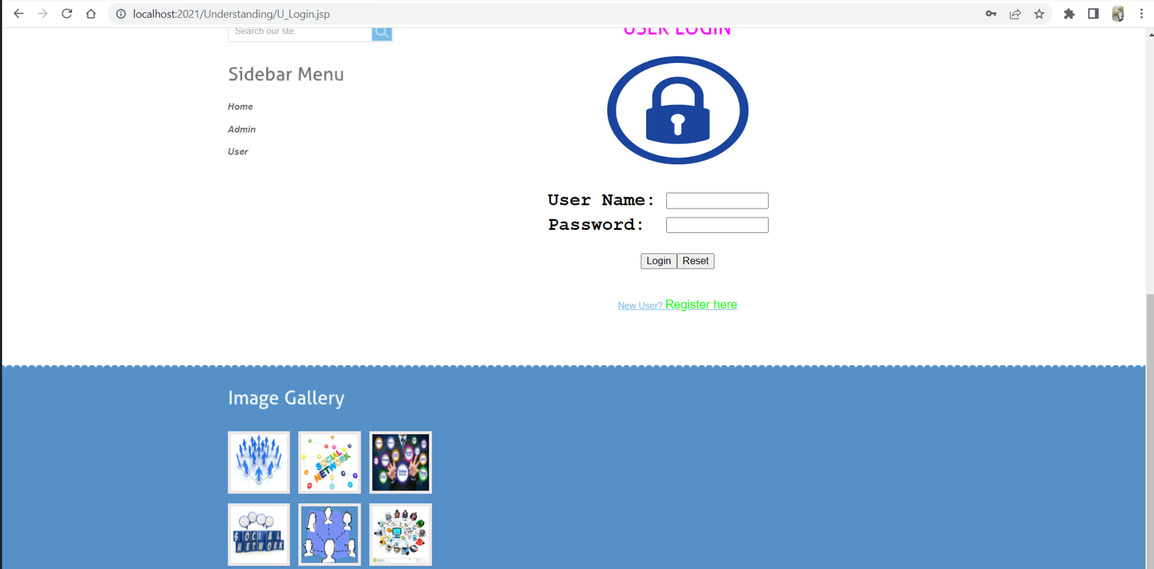

Step 4: By selecting the register here, we need to provide the details of the user.

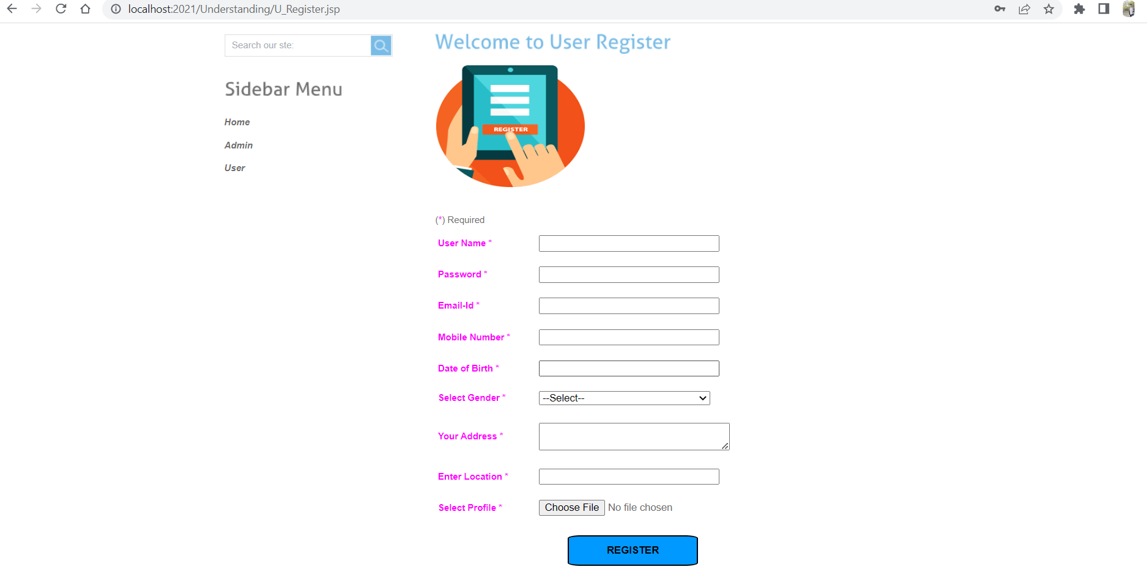

Step 5: In the below screenshot user details are displayed to register.

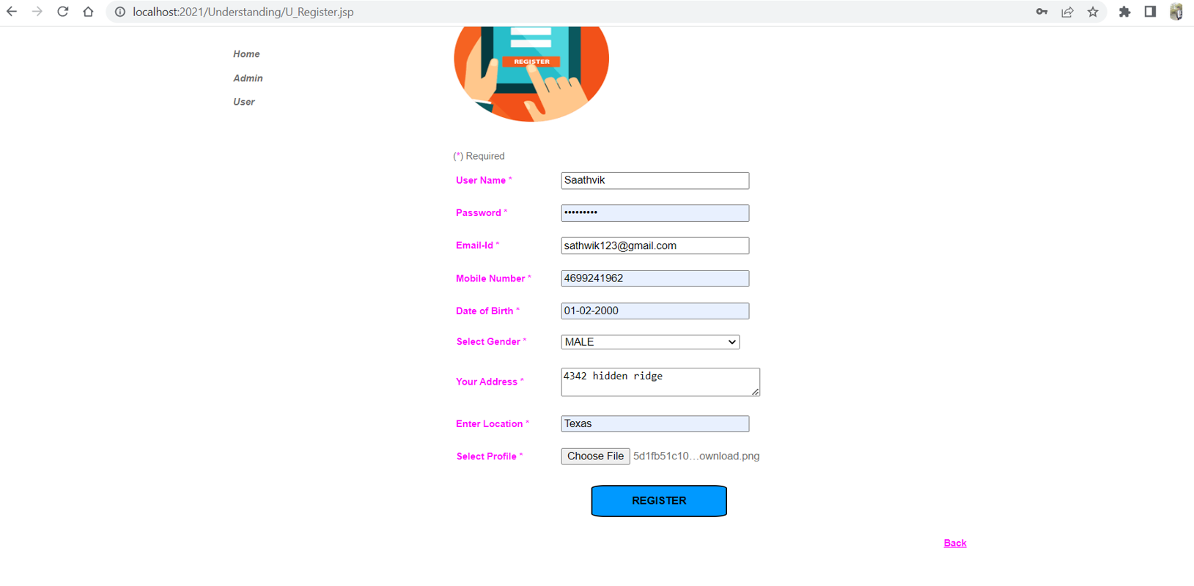

Step 6: This page going to display after the successful completion of the registration.

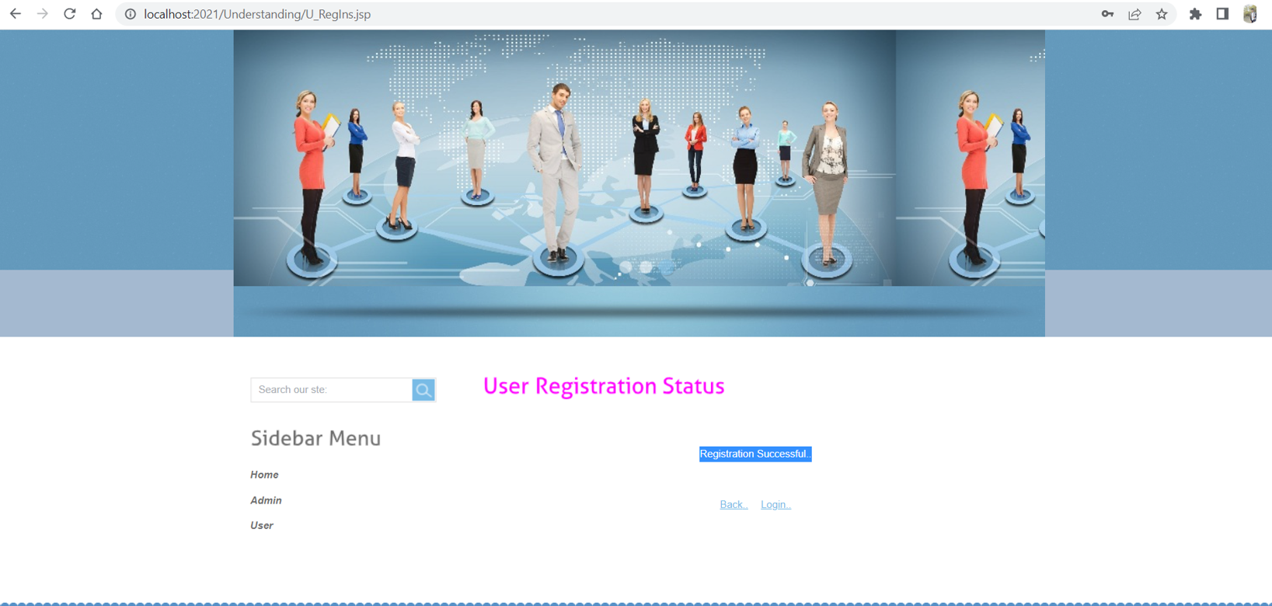

Step 7: Here is the User Login Page

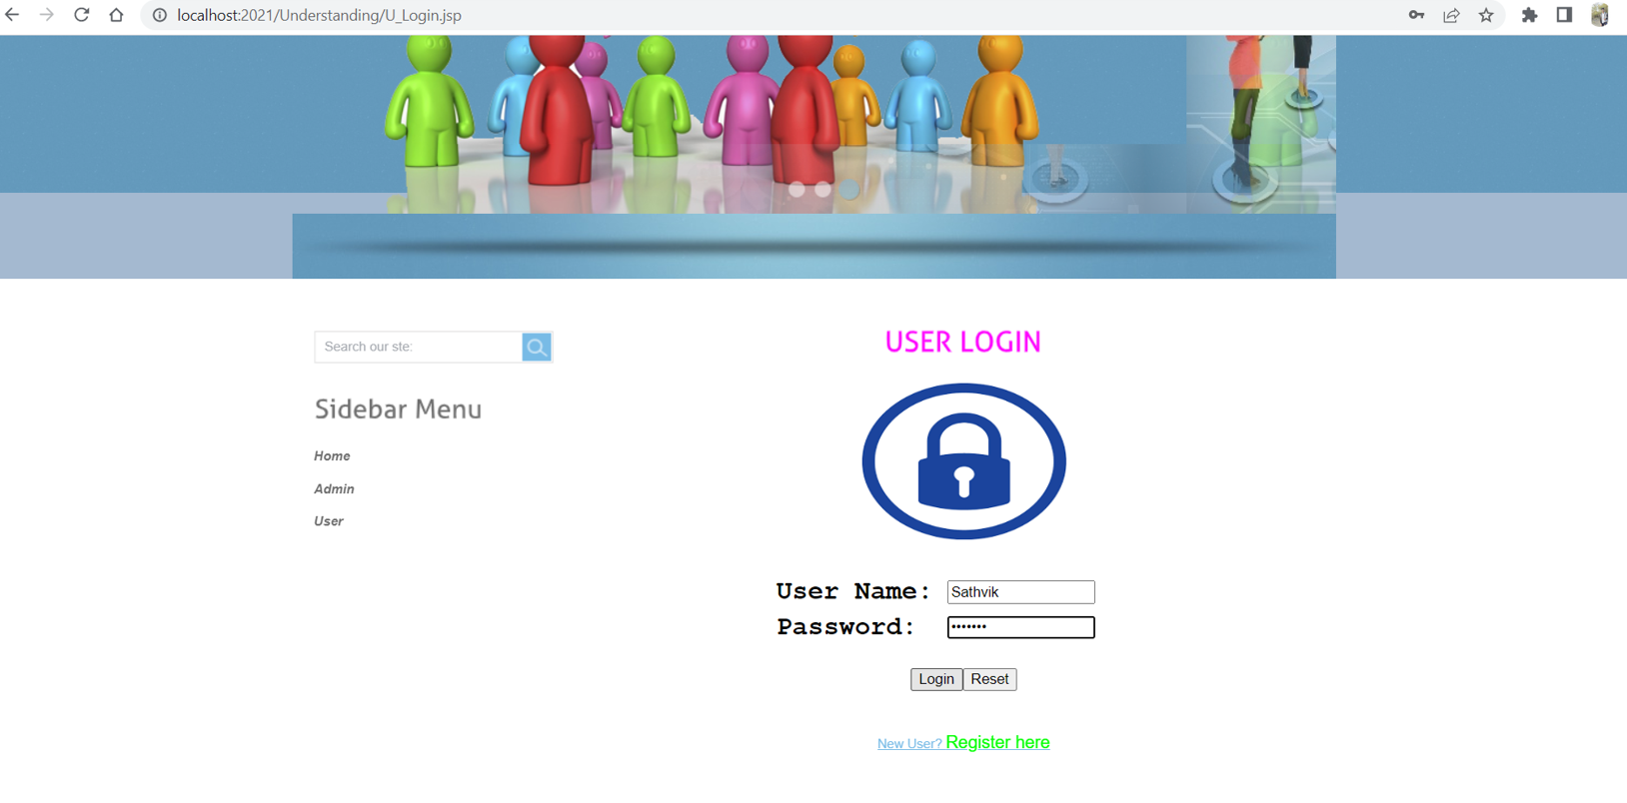

Step 8: Here is the Admin page of the application.

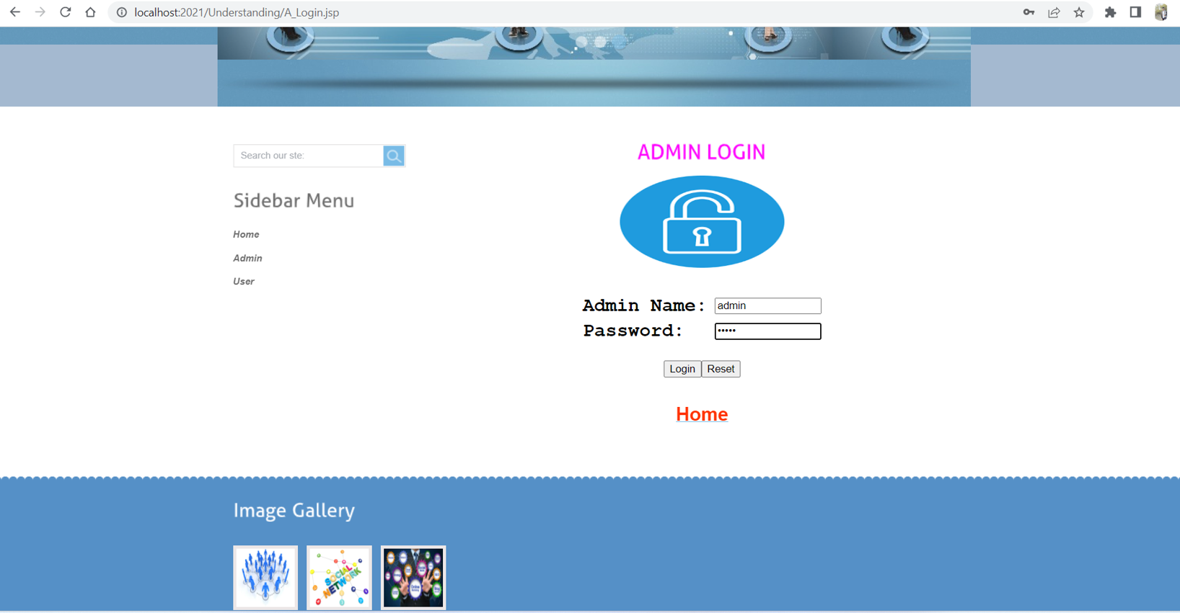

Step 9: In the below screenshots it displays the home page of the admin page.

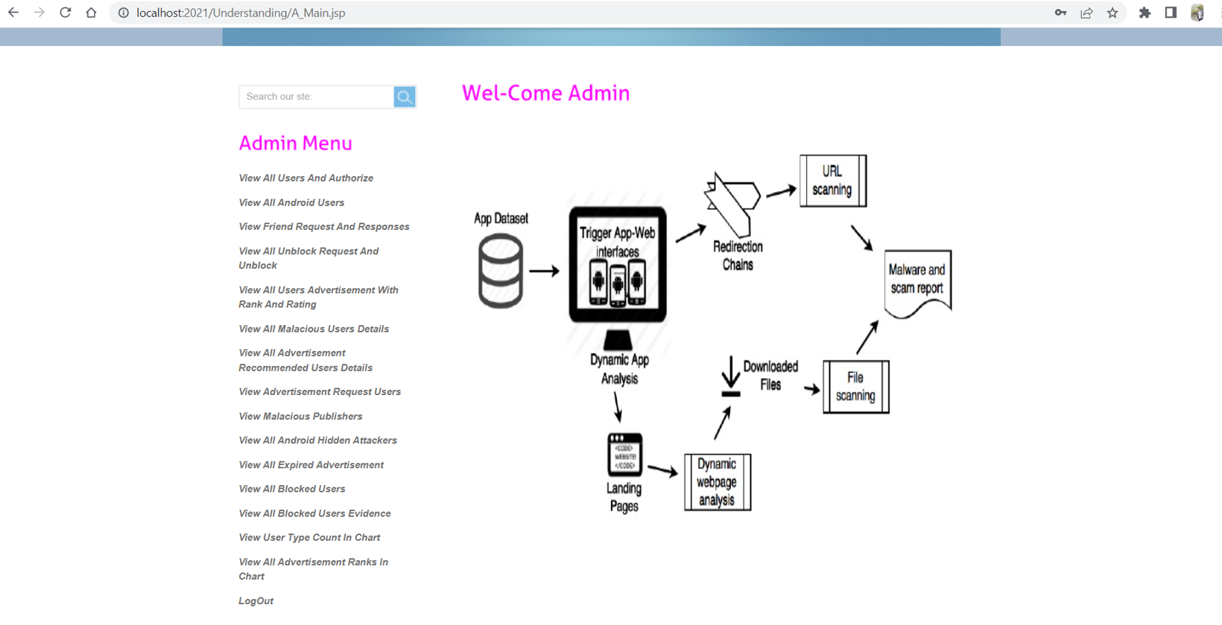

Step 8: By selecting the View All Users And Authorize it will display the below page. Here, the admin needs to authorize the user for login to this application.

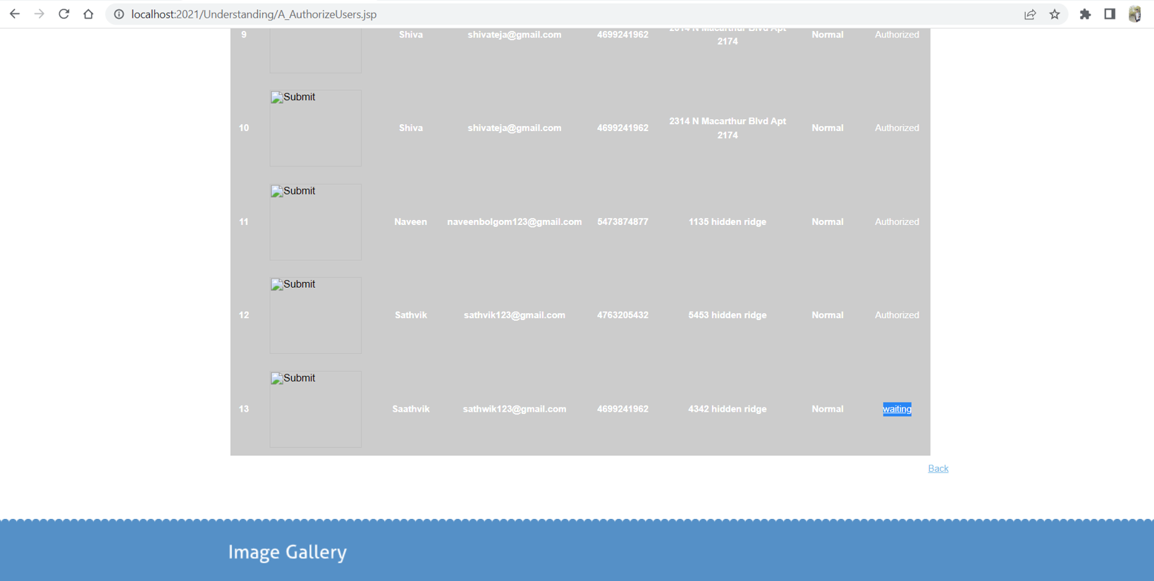

Step 9: After the successful authorization, user can login into their account.

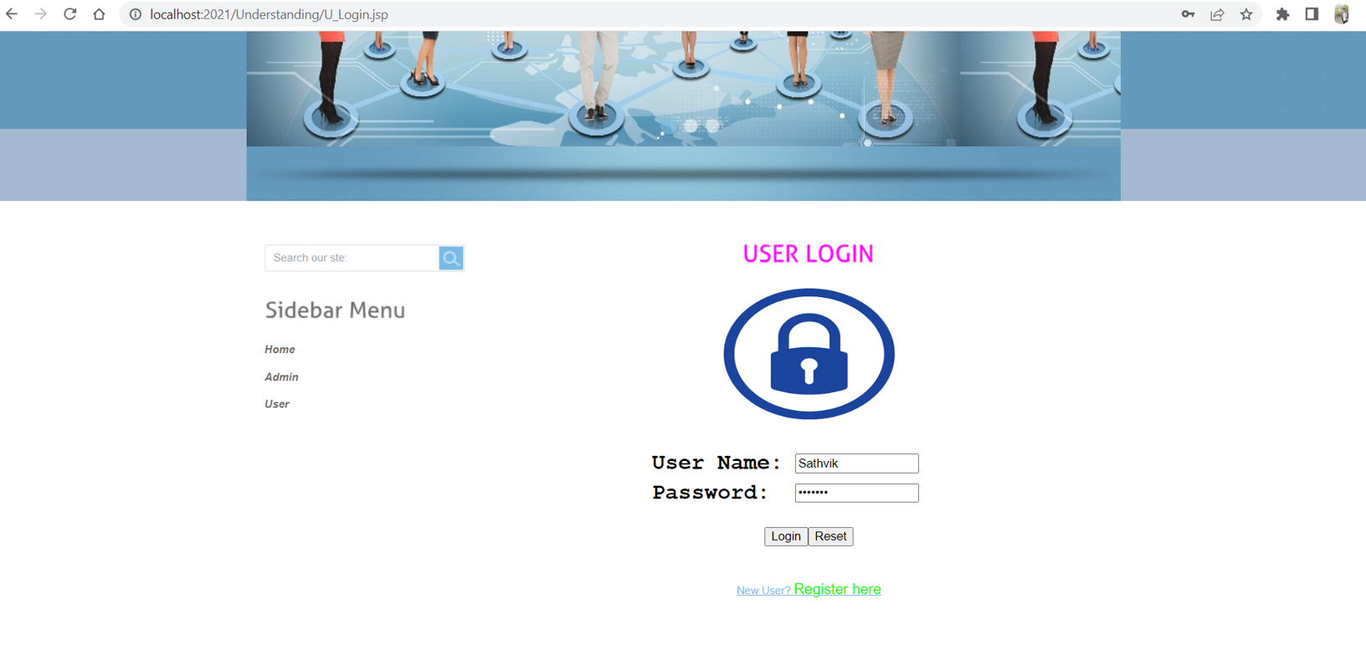

Step 10: Here is the home page of the User.

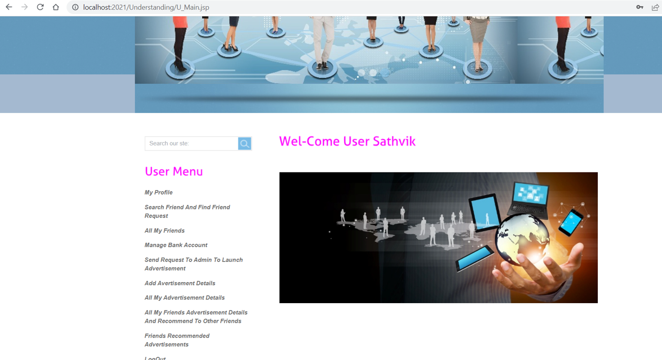

# UML Design

## Class diagram

## 

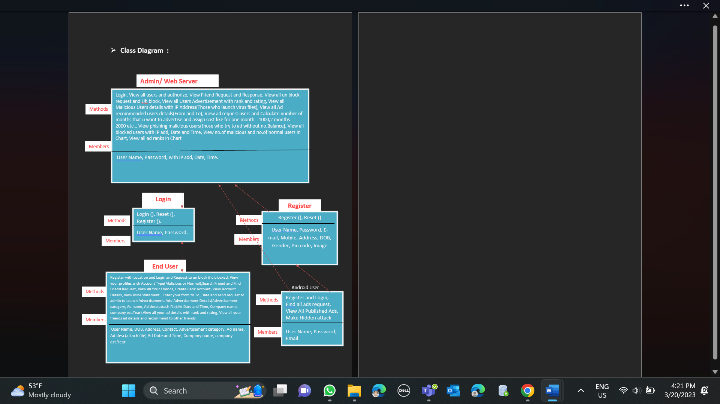

Figure : Class Diagram

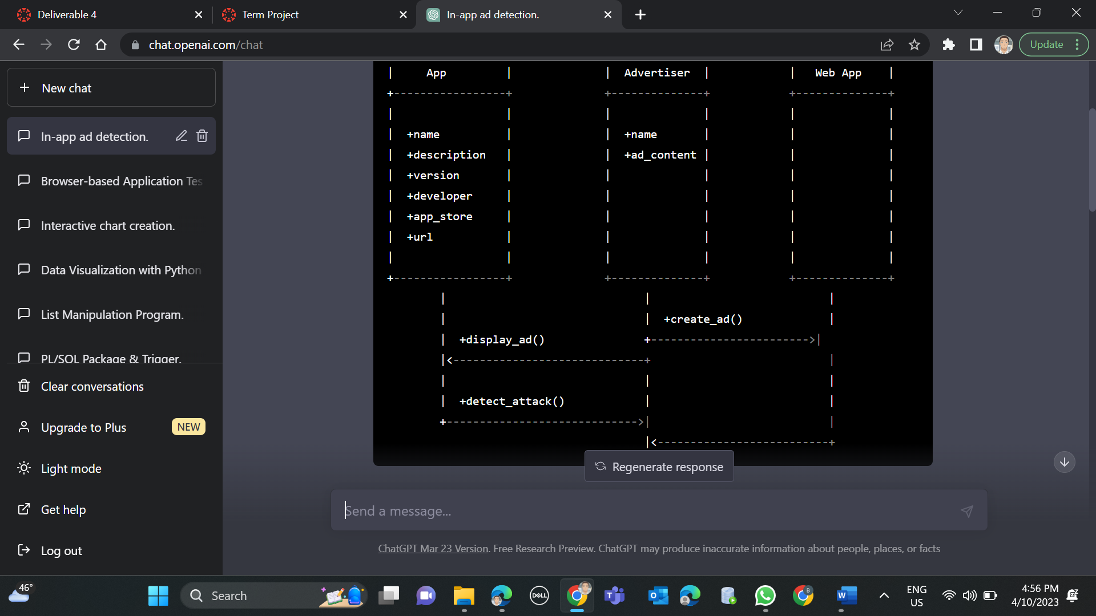

Another Class Diagram defining the application in simple functional format.

## Sequence diagram

Sequence diagram for “Understanding In-app Ads and Detecting Hidden Attacks through the mobile App -Web Interface.” with respect to the Phase – 1 Requirements.

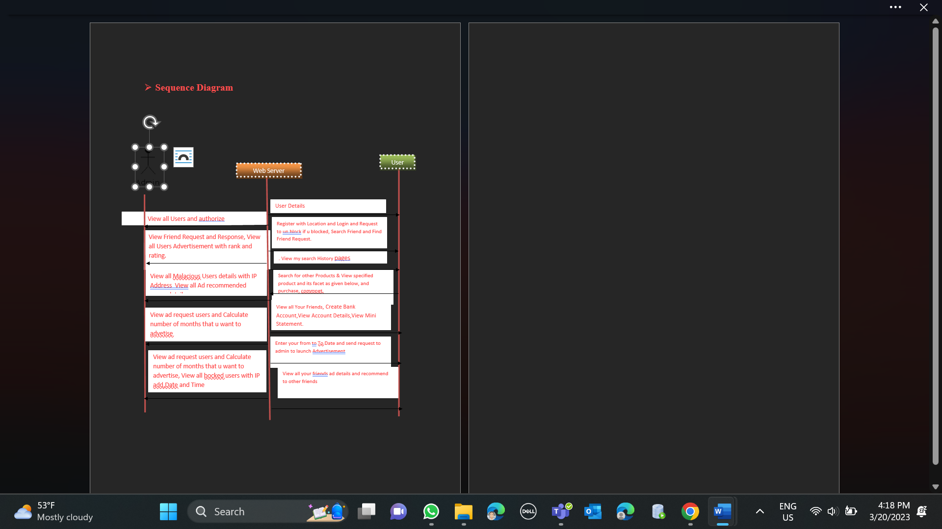

Figure : Sequence Diagram

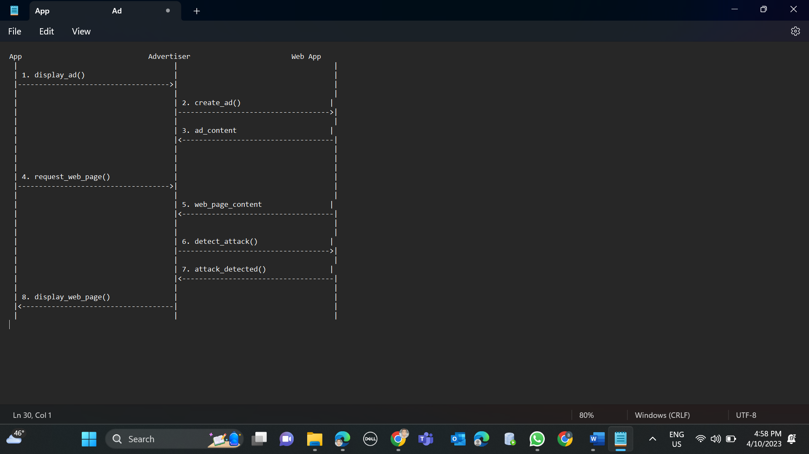

## Use case diagram

Use Case diagram for “**Understanding In-app Ads and Detecting Hidden Attacks through the mobile App -Web Interface.**” with respect to the Phase – 1 Requirements.

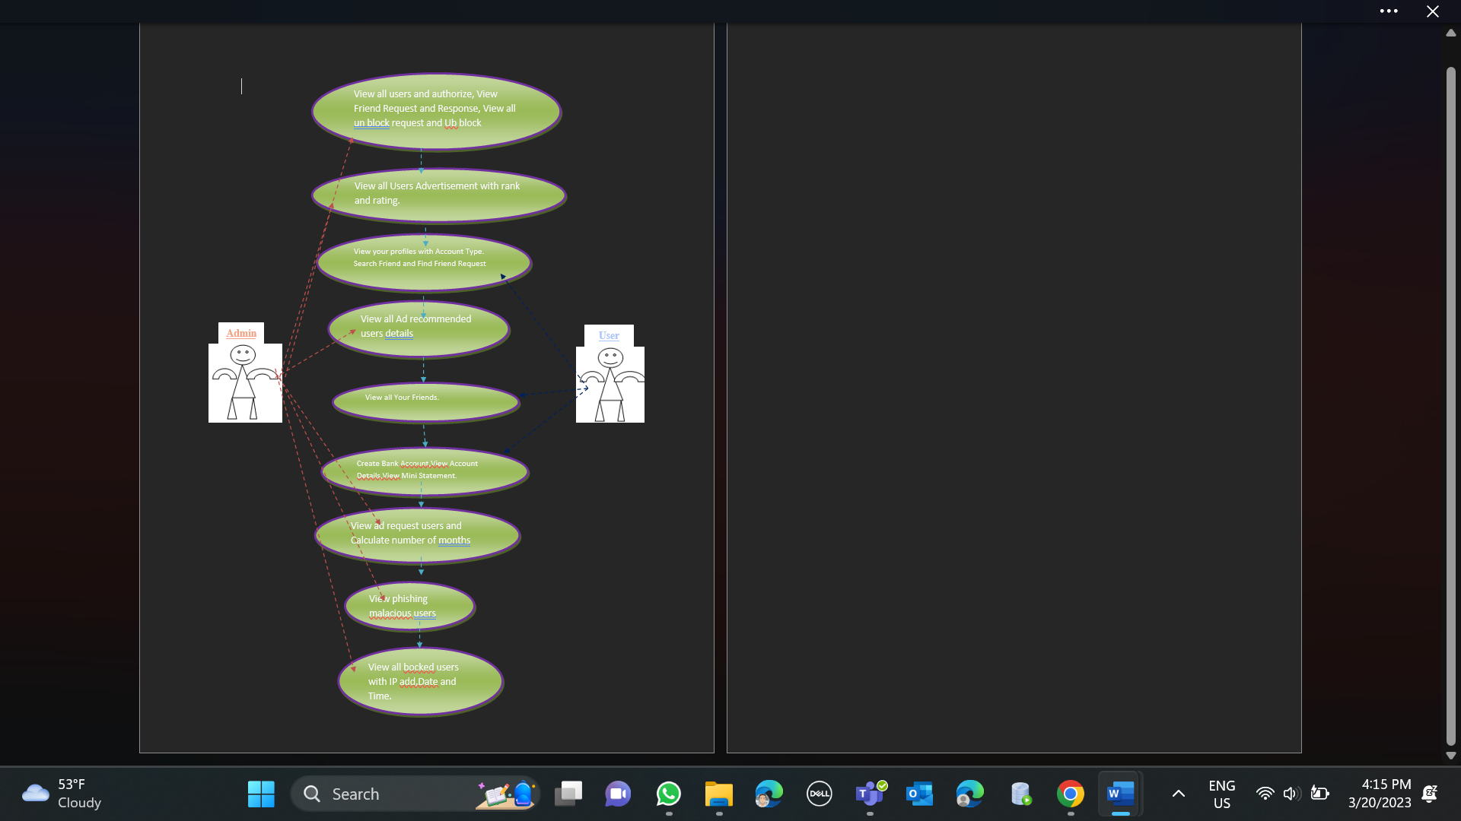

Figure : Use-case Diagram-normal case.

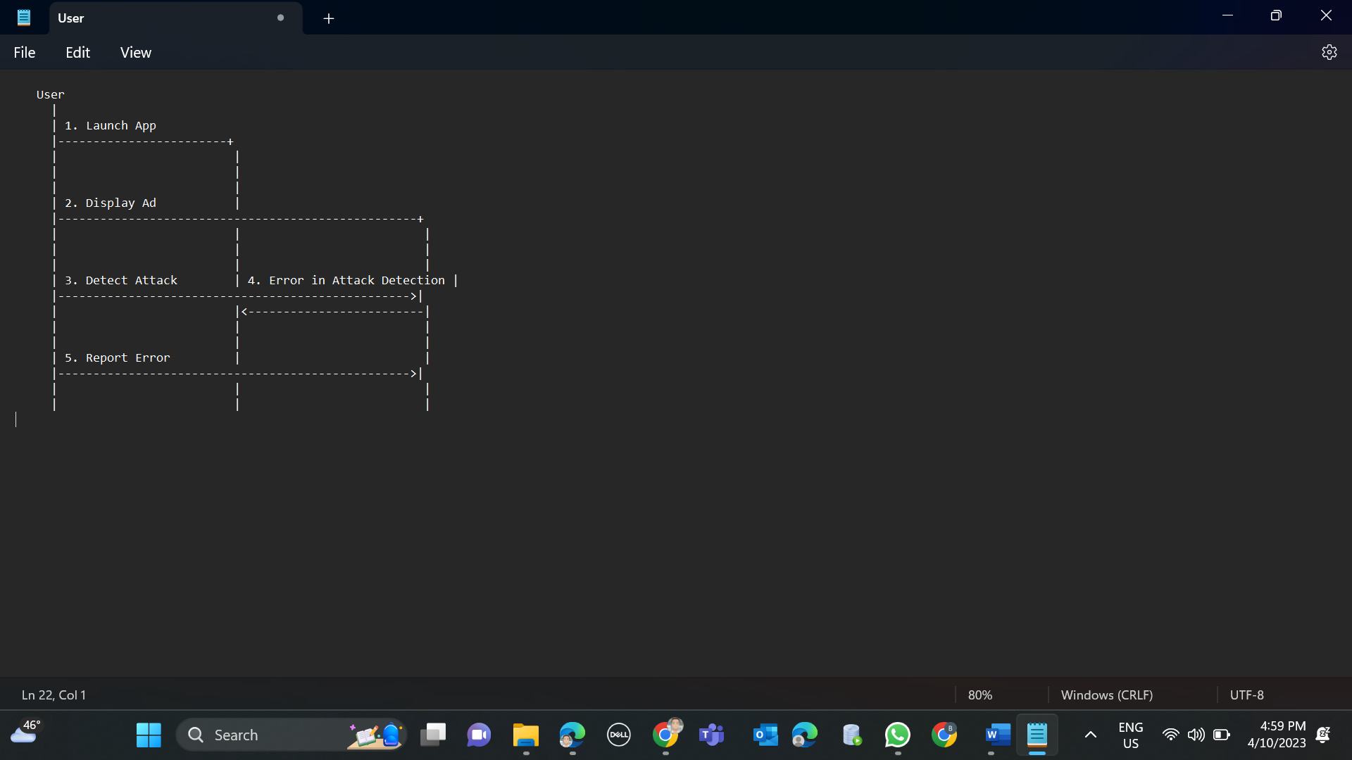

Test Cases

Test Cases:

1. To access the admin page here we need to provide the valid login credentials. If we fail to provide those credentials it will throw error. Based on this condition we tested the application, and the result was Pass.

In the below screen shot admin home page has shown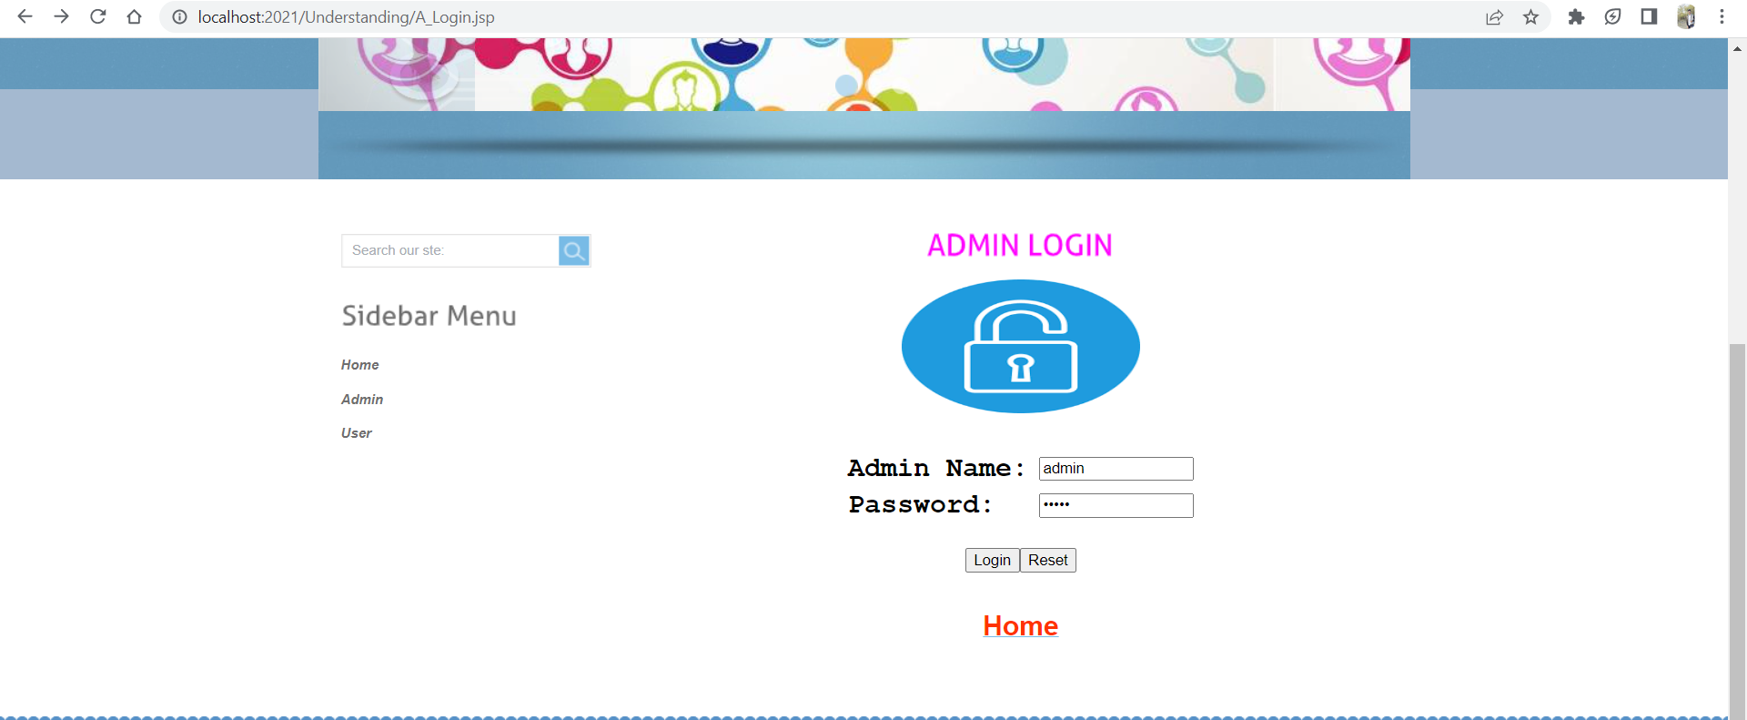

If we gave wrong login credentials, then it will redirect to this page

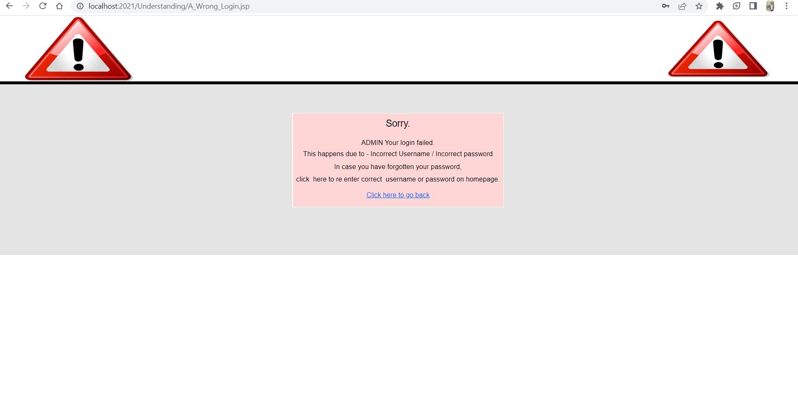

If we gave Correct credentials, it will display the admin welcome page

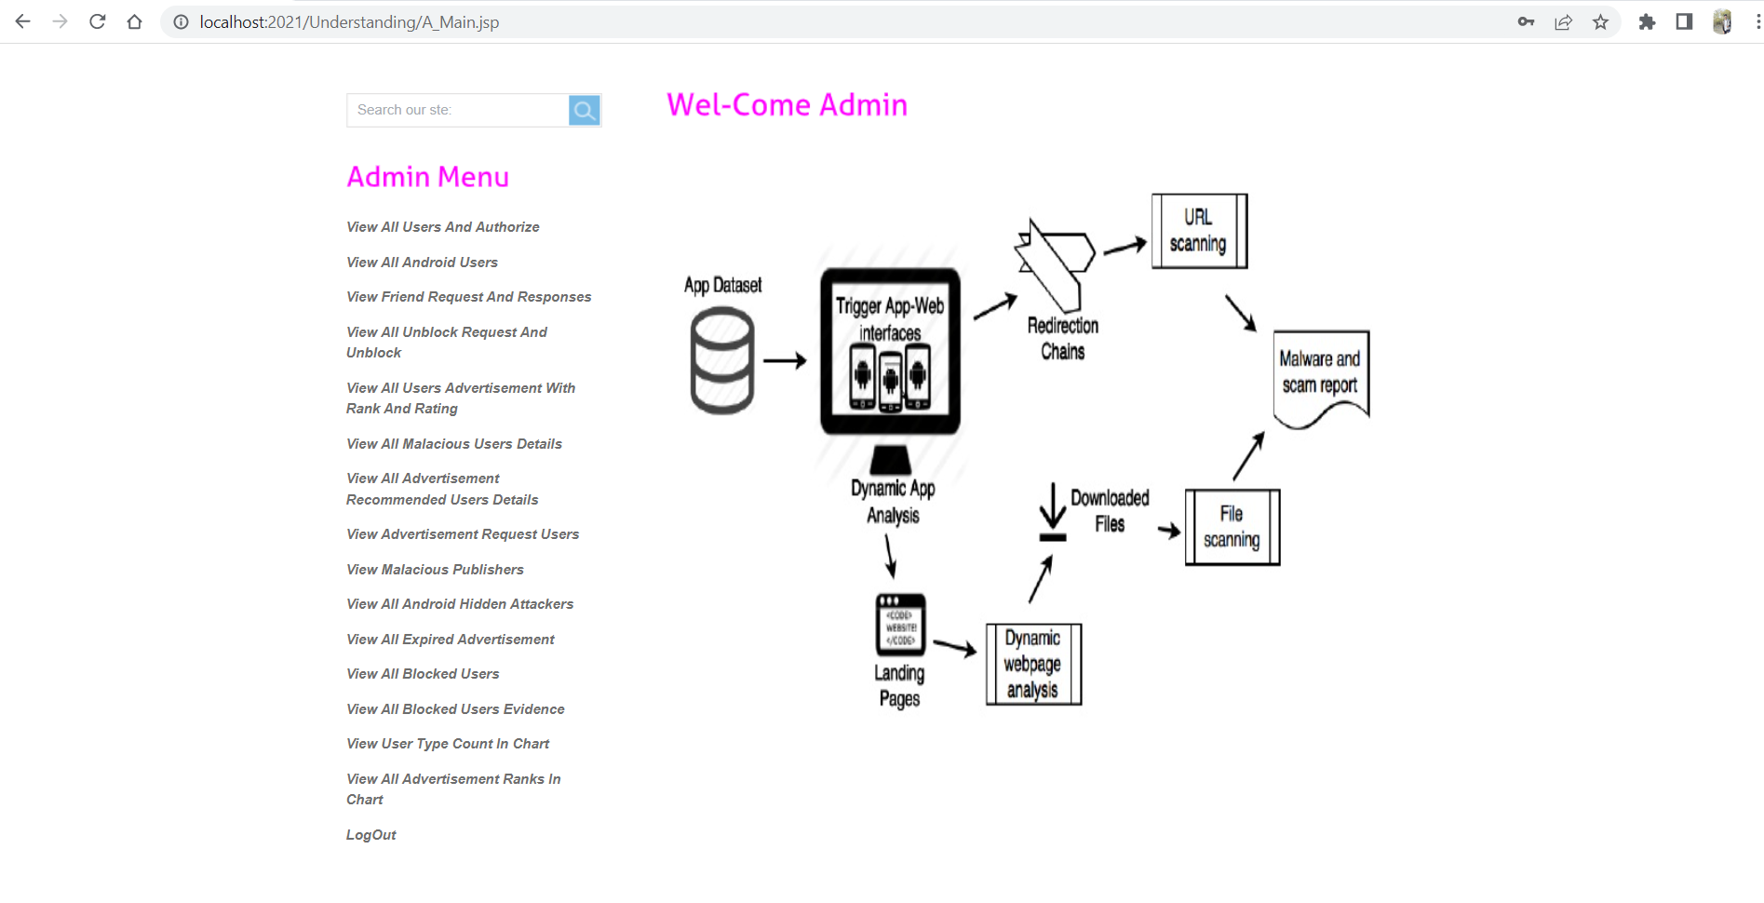

1. Similarly, we tested the user page also. This test case result was Pass.

In the below screenshot We entered wrong credentials.

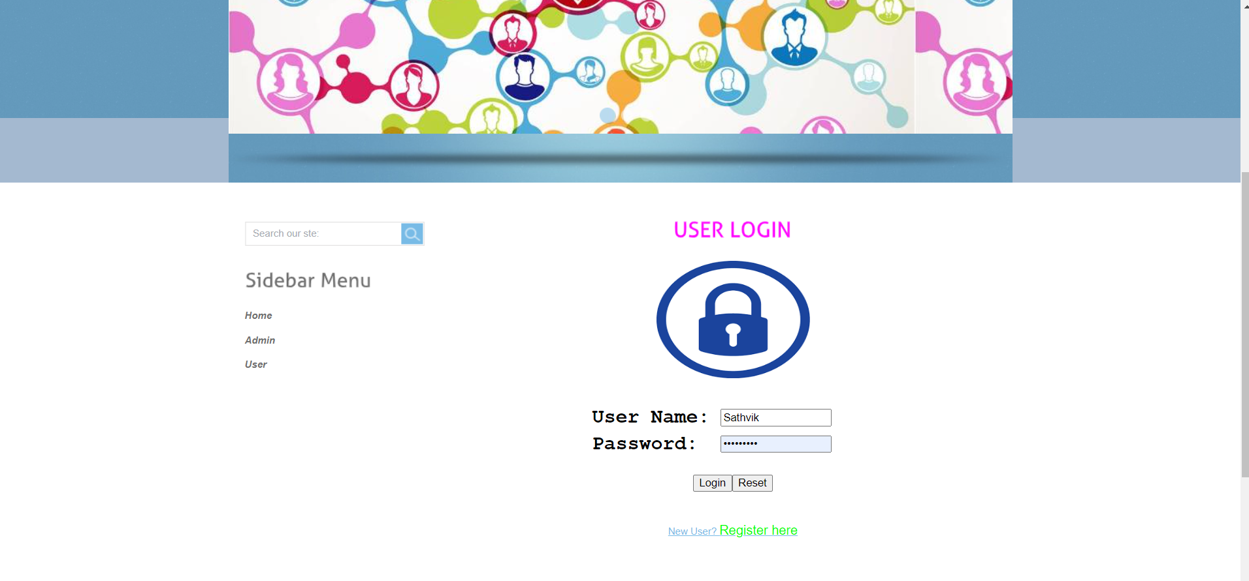

As we entered wrong credentials, the error as shown in the below screenshot

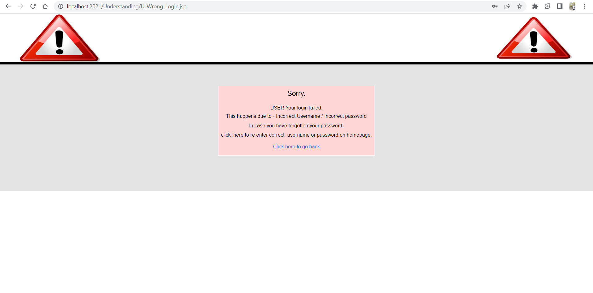

This time I gave correct credentials so, it is navigated to the user welcome page. 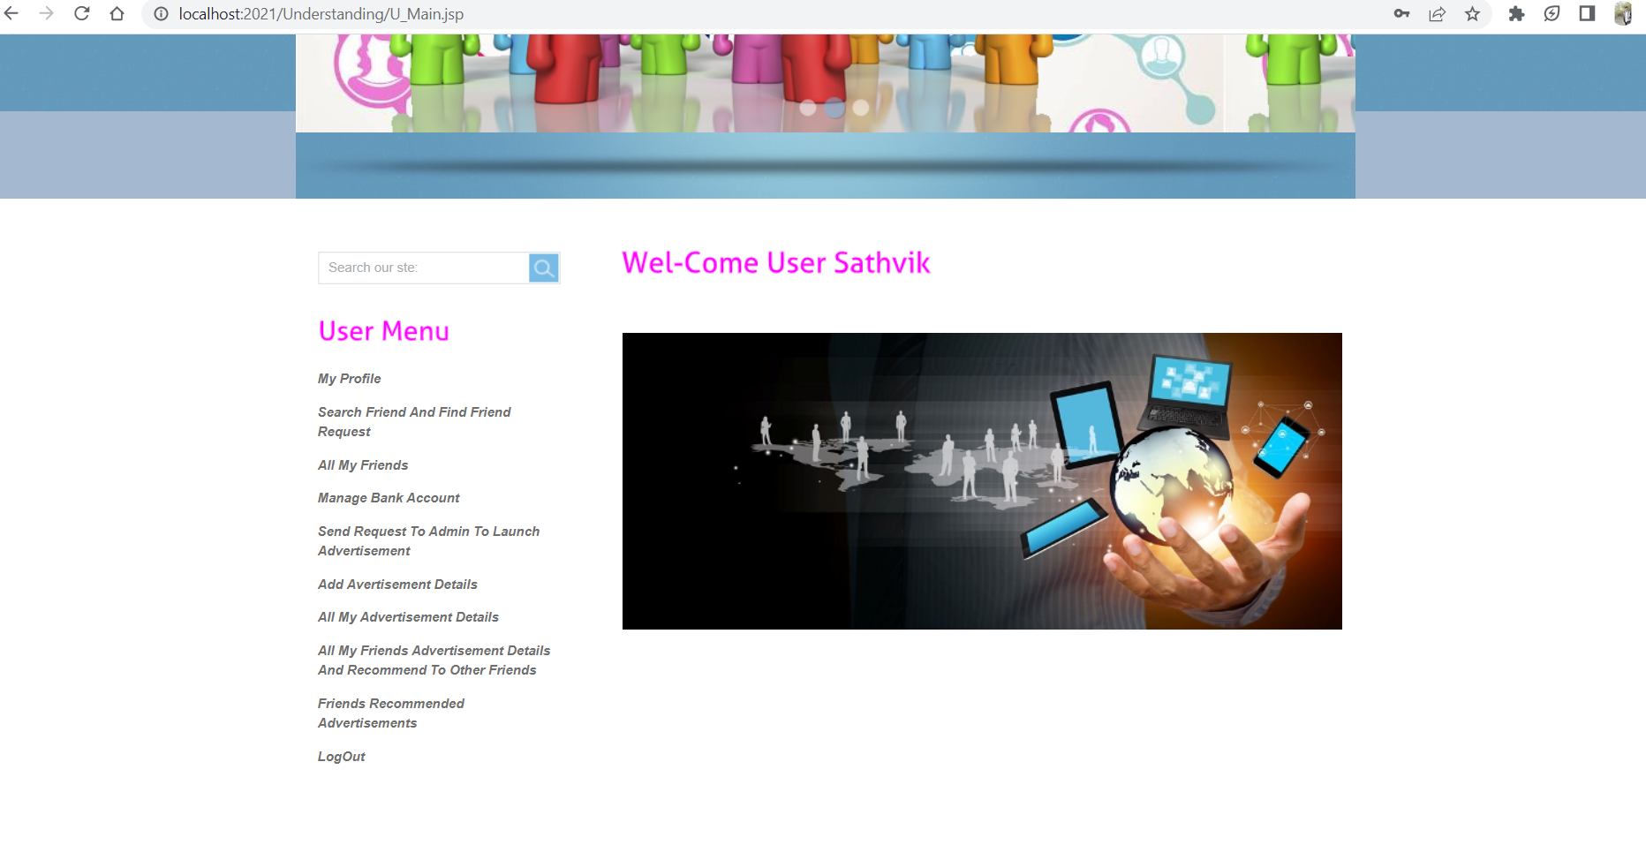

1. In this case we tried to login without giving any credentials, then the pop-up need to show for Please enter the credentials and this testcase result was Pass.

In the below screenshot we displayed popup window.

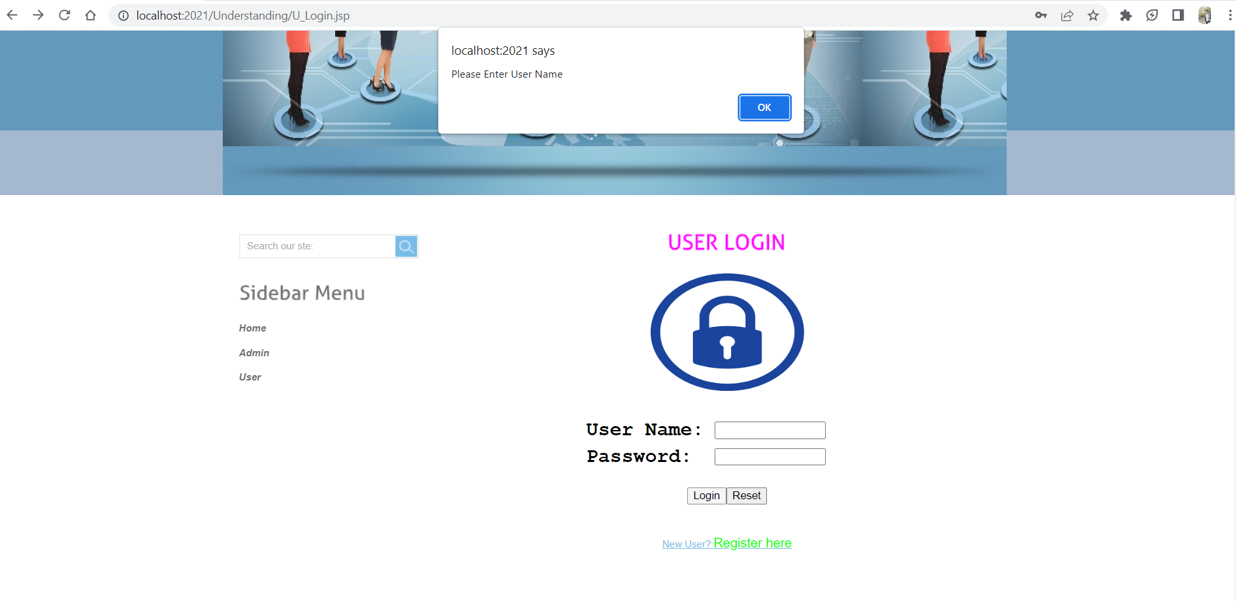

1. If the user is new to this application, he/she need to must register for accessing the webpage. For this case register page also working properly and this test case result was Pass.

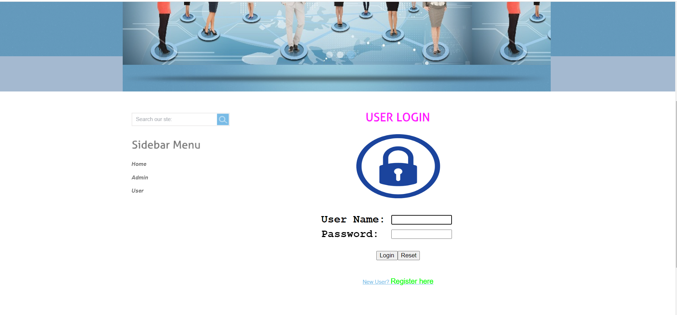

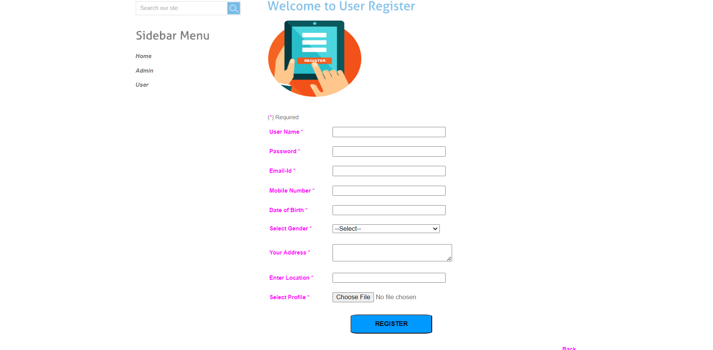

1. In this case we are trying to register without giving any details about the user. Popup windows need to show here for entering the details.

In the below screenshot that is what we shown and result of this testcase was Pass

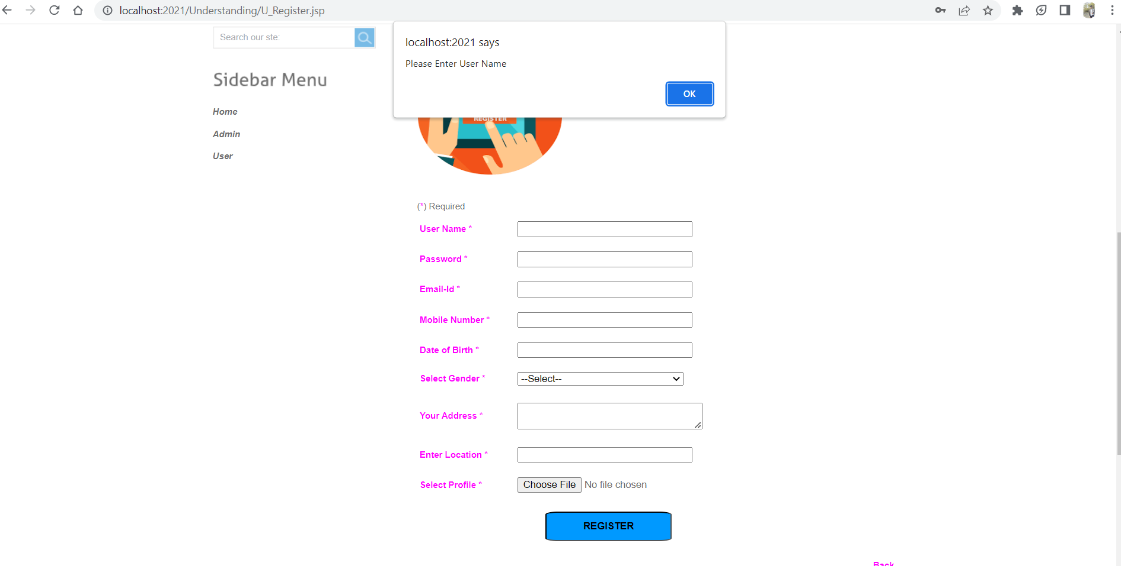

# Program Compilation and Run Instructions

1. **Program Instructions**

To compile and run the program and test cases on your local system, follow the instructions below. Make sure you have installed all required software and dependencies before continuing.

This requires the program to be compiled before it can be run or run.

***Compilation:*** The first step is to compile the program using an appropriate compiler or build tool. This is needed to generate the executable files that can be run on your system.

***Running the program:*** Once the compilation process is complete, you can run your program by running the generated executable file.

Here is a detailed explanation of the steps to compile and run the program on your local system using the Tomcat server.

***1. Download Tomcat:*** To run your program on your local system, you must first download and install the Tomcat server. You can download Tomcat from Apache Tomcat official website. Choose the version compatible with your operating system and download the ZIP or TAR file.  
  
***2. Extract the files:*** After downloading Tomcat, extract the contents of the ZIP or TAR file to a directory of your choice. This will create a new directory containing the tomcat files. You can extract the files using any extraction tool like WinRAR or 7-Zip.

***3. Start the server:*** To start the tomcat server, navigate to the bin directory of the tomcat directory you just extracted and run the startup application called Tomcat8.exe.

Here is the detailed explanation of the steps to follow to compile and run the program on your local system using Tomcat server.

1. **Download Tomcat:** To run your program on your local system, you first need to download and install Tomcat server. You can download Tomcat from the official Apache Tomcat website. Choose the version that is compatible with your operating system and download either the ZIP or TAR file.
2. **Extract the files:** After downloading Tomcat, extract the contents of the ZIP or TAR file to a directory of your choice. This will create a new directory containing the Tomcat files. You can extract the files using any extraction tool that you prefer, such as WinRAR or 7-Zip.
3. **Start the server:** To start the Tomcat server, navigate to the bin directory of the Tomcat directory that you have just extracted, and run the startup application named ‘Tomcat8.exe’.

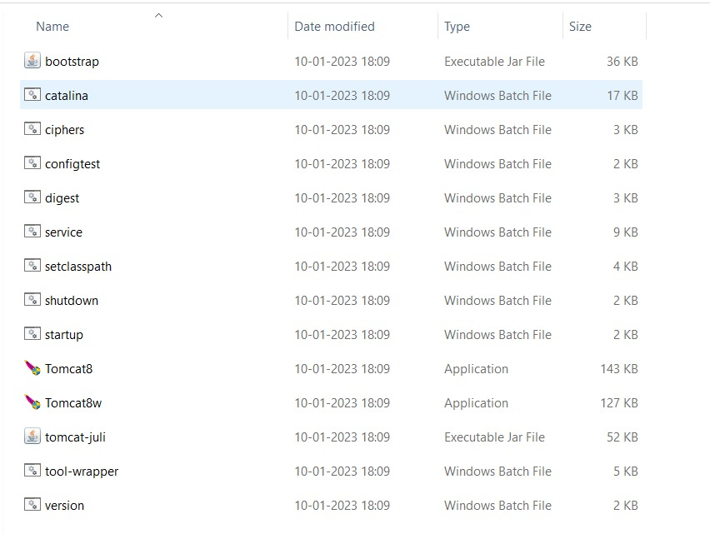

This will start the server as shown in the below screenshot and make it accessible at <http://localhost:2021/>.

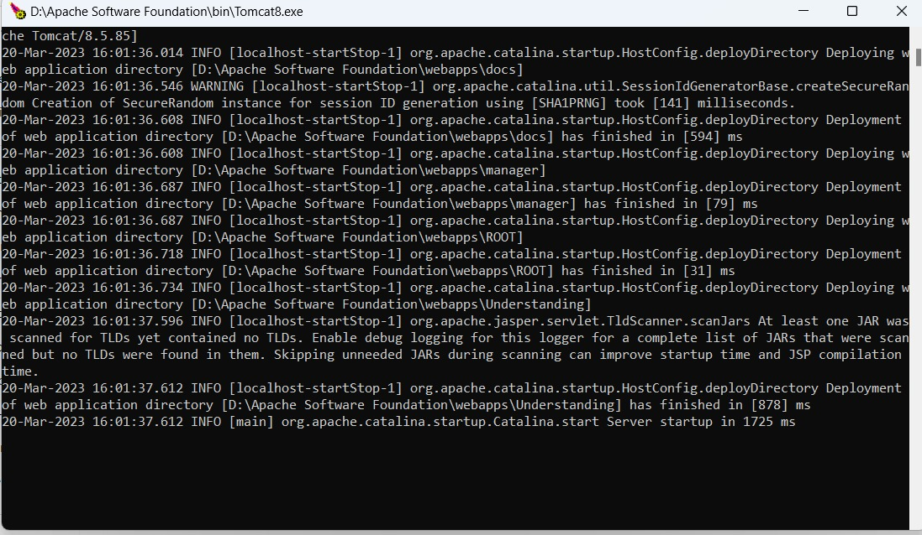

1. **Verify the installation:** For the verification of running the Tomcat server successfully, choose any web browser of your choice, open it and run the address as <http://localhost:2021/> . You can observe the Tomcat home page which is the default page of the application as in below screenshot. This confirms that Tomcat is running correctly on your system.

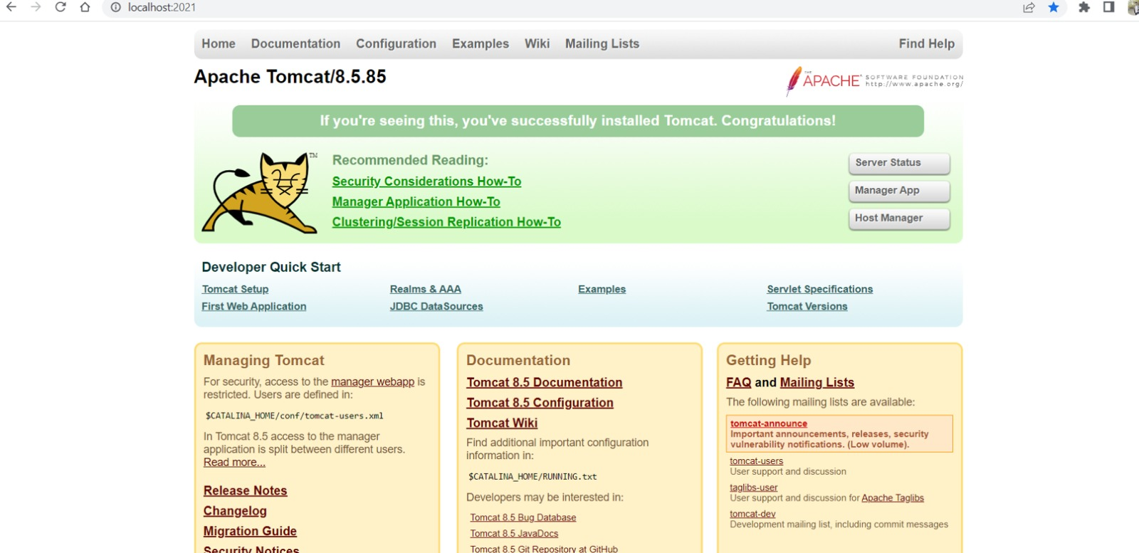

1. **Navigate to the application:** To navigate to the application’s home page, click on the Manager App button, which will take you to the Tomcat manager page where the list of all the available applications is showcased as in below screenshot.

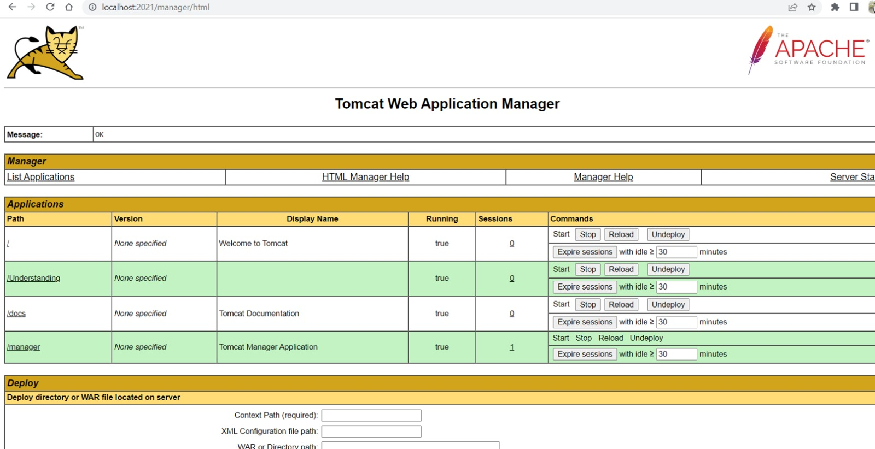

From there, click on the application that you want to run. As our application is ‘/Understanding’, click on that. If your application requires any credentials or login details, you will be prompted to enter them at this stage as shown in the screenshot below. For our application admin credentials are required.

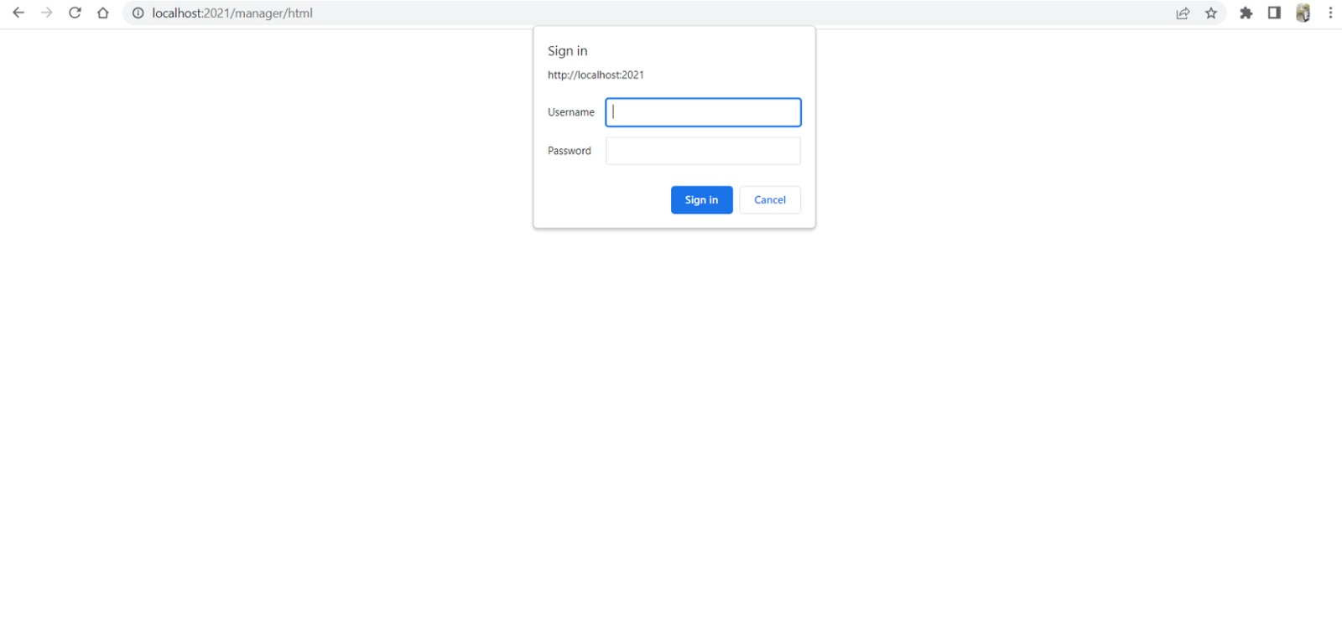

Congratulations, you have successfully installed and configured the Tomcat server and your application on your local system.

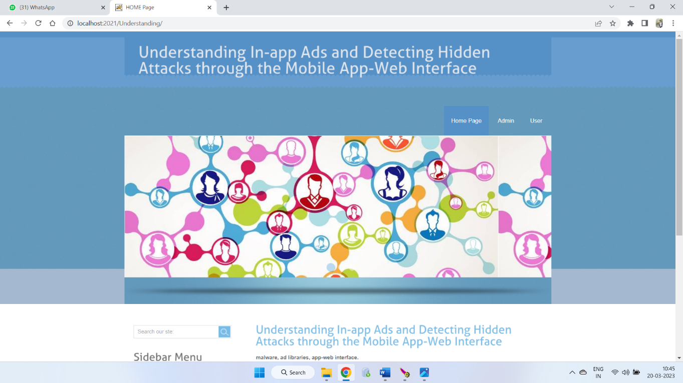

1. **Closing the server:** To stop the Tomcat server, navigate to the bin directory of the Tomcat directory and run the application named ‘Tomcat8w.exe’. This will open a command pallet where you can see that the server has been stopped.



1. **Testing Instructions**

This project is developed as a web application, which means it runs in a web browser. Therefore, to test the application, you must launch it in a web browser and run the program directly in the browser. The web application provides a user interface that allows you to interact with the program and test its functionality. By running the program itself in the browser, you can verify that the output generated by the application is correct and matches the expected output.  
  
To ensure that the application works properly and meets the required specifications, test the application by following the steps below:  
  
1. **Configure the application:** Make sure you have correctly configured the application on your local system by following the installation and configuration instructions provided.  
  
2. **Launch the application:** Launch the application by accessing the

URL http://localhost:2021/ in your web browser. This should take you to the app's home page.  
  
3. **Test each function:** Test each function of the app using the provided user interface. Make sure all buttons, links, and forms work as expected. Thoroughly test each feature of the application according to the test cases provided above to ensure that it meets the required specifications.  
  
4. **Verify output:** Verify that the output generated by the application is correct and matches the expected output. Make sure your application can detect and prevent attacks hidden in in-app ads.  
  
5. **Edge case testing:** Test the application with different inputs and edge cases to make sure it handles all possible scenarios correctly. Make sure your application can properly handle unexpected inputs and errors.  
  
6. **Retest**: Repeat the testing process multiple times to ensure consistency and reliability of the application.  
  
In summary, to compile and run the program and test cases on your local system, you need to compile the program, run the executable file, and use the web application UI opened in a web browser to run the test cases. By following these steps, you can ensure that your program works properly and meets the required specifications.

## Testing Instructions

As it is web application, most of the test cases executed as a part of Phase-1 were directly evaluated on the browser. Below are the steps:

The first step in testing is to prepare the application. In this case, the application is a web-based program that runs directly on the browser. Therefore, we will test each function of the program directly on the browser.

# Feedback

**Feedback Received:**

1. ***User Interface Design:*** Enhance the design of login and registration pages to make them more visually appealing and user-friendly.
2. ***Security:*** Address potential security vulnerabilities in the code including additional checks to ensure proper validation and handling of user inputs.
3. ***Block and Unblock Feature:*** Implement a feature that enables users to block and unblock other users in the application.
4. ***External Bank APIs:*** Integrate external bank APIs to allow users to use their existing bank accounts within the application.

**Accepted:** Actions taken based on feedback

• The partner's team suggested improving the user interface design for the login and registration pages. Our team agreed and implemented a more visually appealing design to improve the overall user experience. We've added a theme to the sign up page and improved the design of the buttons to make them more noticeable. The goal was to make the registration process smooth and easy to use and to leave a positive first impression of our platform.  
• The partner team had suggested implementing a feature to block and unblock users in the application. Our team took the suggestion and implemented it in our application. This feature allows users to temporarily or permanently restrict other users' access to certain features or content of the application. Users can block another user by clicking the "Block User" button in the user's profile. Once a user is blocked, they cannot send messages or communicate in any way with the blocking user. The blocking user can also choose to unblock the user at any time and restore access to the application's features and content. This feature has been successfully implemented and tested, and we are confident that it will provide our users with an even safer experience.  
• Based on feedback received, the team updated the code to include additional checks and validations for user input. This included implementing more robust input validation features that detect potential vulnerabilities and prevent their exploitation.

**Rejected:**

* *Security of the project*: acknowledged that the security of the project is a concern but may not be able to implement advanced security features due to time constraints and complexity.
* *Use of external bank APIs:* acknowledged that this feature would improve user experience but may require significant technical resources and ongoing coordination with external banks.

# Accomplishments

A Complete reflection of work for this phase:

1. In this Increment we worked on all the three modules of the project and the database.

2. In the Admin Module we worked on the changes should be made to the other modules according to the request raised by the other users like functionalities triggering to permit the request of posting adds and blocking users according to the ads posted.

3.In the Mobile User module there should be the functionalities affecting the database according to the requests made by the admin side.

4.Updating the database according to the modules requirement with some extra records and also some new attributes(Columns) for effective working of application.

# Member contribution table

|  |  |  |  |
| --- | --- | --- | --- |
| **Member Name** | **Contribution Description** | **Overall Contribution (%)** | **Note (If Applicable)** |
| **Sushma Bobbishetty** | Functional and Non-Functional requirement specification and Full Stack Development, worked on all components. | 15 |  |
| **Sathvik Cheekati** | Program Compilation and Run Instructions. Front-end development of customer, employee, and manager modules. | 16 |  |
| **Navyasri Arekatla** | Test Cases and Back-end development of customer, employee, and manager modules. | 12 |  |
| **Naveen Bolgom** | Feedback and accomplishments. Back-end development of customer, employee, and manager modules. | 12 |  |
| **Lokesh Bachu** | Code-inspection document. Front-end development of customer, employee, and manager modules. | 15 |  |
| **Vamshi Teja Goud Puli** | User Manual and Application Layer Development. UML Designs and Initial Integrated Testing. | 13 |  |
| **Shiva Teja Reddy Yammanuru** | Code-inspection document and GitHub update and Application and UI Development. | 15 |  |

# VIII Reflection

In this phase of the project, we achieved the following:  
  
1.  Continued application layer development using Java servlet pages to improve web interface functionality and performance.

2. Updated front-end web pages for all modules to include additional functionality and improve user experience. We continue to use Ajax, jQuery and Servlet pages for backend development.

1. Necessary database updates to ensure it maintains a good flow in all areas of the project.
2. Continued backend development for updated admin, user and Android modules to ensure all functionality is properly integrated into the database and system architecture.
3. Implemented the functions received from the peer team proposal, which were obtained during the code inspection workshop.
4. Perform in -depth tests to ensure that the system is working properly and is free from errors. We provided the Apache Tomcat server to the application and carried out in -depth tests to ensure that all functions work as expected.  
     
   Overall, the team has reached important milestones in the development of the project, in particular the creation of a functional database, the development of applications and front layers and the integration of various components. We were able to successfully update more features as well as suggestions from the partner team resulting in improved application security, user interface and overall user experience. Our team has remained collaborative and effective, with regular training sessions to ensure everyone is on the same page. However, we could have improved communication and collaboration between team members, and we could have also improved the testing process by conducting more extensive and extensive testing before deploying the application.